Meeting Proceedings Reflective Summary
Student’s Name:
Institutional Affiliation:

Meeting Proceedings Reflective Summary
The meeting that took place on July 16, 2019, at Miami Dade County, the office of the United States Department of Housing and Urban Development was held by the committee members in the presence of the mayor addressing issues regarding community development and housing conditions. The meeting was held by various members of the housing committee and funding programs aiming to develop an action plan that will aid the funding process and grant acquisition for the Community Development Block, various housing investments, different aspects of emergency resolutions, funds for multiple programs including home recapture and reallocate among various other programs aimed towards the development within the community. The Board of the County Commissioners dwelled on the agenda of housing, aspects of social facilities, and the need for economic development within the community. The allotted programs were to be achieved through funding programs, and some of the basic recommended aspects included facilitation of economic development, enhancing the service of the public and general administration.
The Board of Commissioners had an array of agendas which they consider a core priority in the meeting proceedings. The housing development was one of the central aspects that were discussed in the meeting through an establishment of various forms of programs that will ensure the recapture of the housing facilities among individuals within the community. Programs involving Home investments partnerships were designed with the need of providing and expanding most of the houses among different members. The initiatives ensured a decent, safe, affordable, and well-administered housing. Some of the recommendations that were provided within the meeting as the programs to ensure these facilities include new housing constructions and rehabilitations, making most of the rental houses and apartments to be affordable in relations to the income among various members and offering support among other initiatives.
The Board also showed commitment towards ensuring the economic development among the low- and moderate-income earners within the county, the residents and neighboring members at large. These initiatives were regulated through the Housing and Urban Development program and its objectives that were aimed towards the attainment of community developments through various partners. The main aspect of this agenda was the economic development and growth, and several partners were to ensure that these provisions are achieved through improving the capital need among the residents and other members. The revolution during this meeting involved the acquisitions of aspects and processes with which individual lives can be enhanced not just to obtain affordable housings but also ensuring the general nature of their livelihood are attained within the community. The Board Committee made recommendations that were to be actions plans towards economic development.
The participating Board of County Commissioners reached significant decisions regarding the Action Plan for the community development especially involving the housing developments, ensuring economic growth and provision of efficient services to the public through initiating grants and project funds. These were aimed towards different community development partners with the hope of investing in most of the projects identified during the meeting. The accompanied meeting resolved to target the Public Housing Departments and Community Development Officials in conjoining the request to various partners, committees, and initiatives. The central aspect of the discussion requested permission for the approval process of safe, affordable, and secure housing facilities. The need to ensure the housing developments within Miami required the approval process of major authorities which were also highlighted.
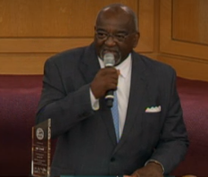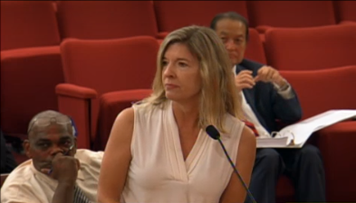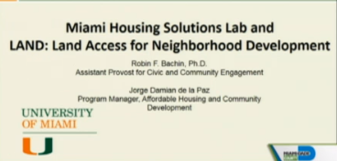

References
http://miamidade.granicus.com/MediaPlayer.php?view_id=2&clip_id=5648

